Quick notes:
- Do not indent as you type.
- Make all chapter headings, “heading 1” font
- No, iBook does support text boxes, images, and fonts outside of Times New Roman, Calibri, and Garamond
- Do not add page numbers.
- Remove all headers and footers.
- The title of your book should be on the very first line of the page or your book will show as untitled when uploaded.
- Title and author name should be center on cover page.
- Your book cover is uploaded separately
- Cover page, dedication, preface, prologue, copyright, foreword, and EVERY chapter title must be “Heading 1”
- Sub chapters within a chapter should be heading two and so forth and so on.
- Nook supports up to four “headings”
- Font doesn’t need to be too big, since Nook users can change the font size from their device.
- The margins do not matter. Your document can remain 8.5X11

Table of contents:
When your document is converted into an epub, the converter will insert your Table of contents. Just be sure all of your headings are labled properly.

Indenting:
Use this method to add indentions to your Kindle book. Hitting the enter key and using tab to indent can create unwanted spaces in your kindle book. Spaces will ruin the entire format and it will not appear on Kindle the way it looks on your word document.
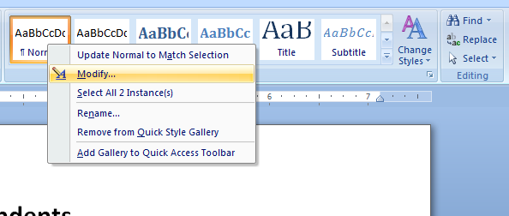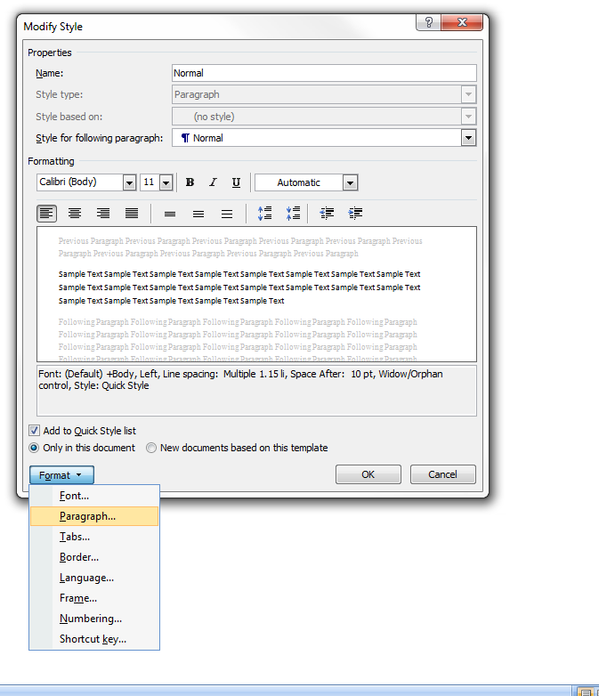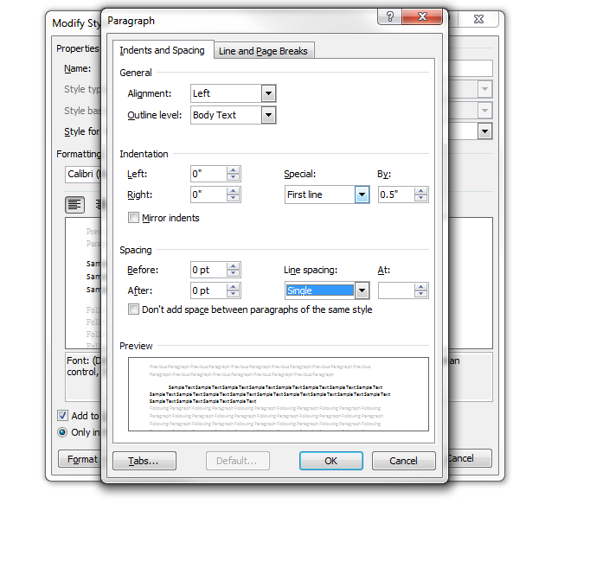

Formatting:
To avoid unwanted spaces and lines use the show/hide key:
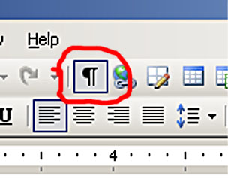
Insert your page breaks found under the “insert” tab. Remove all unwanted spaces.
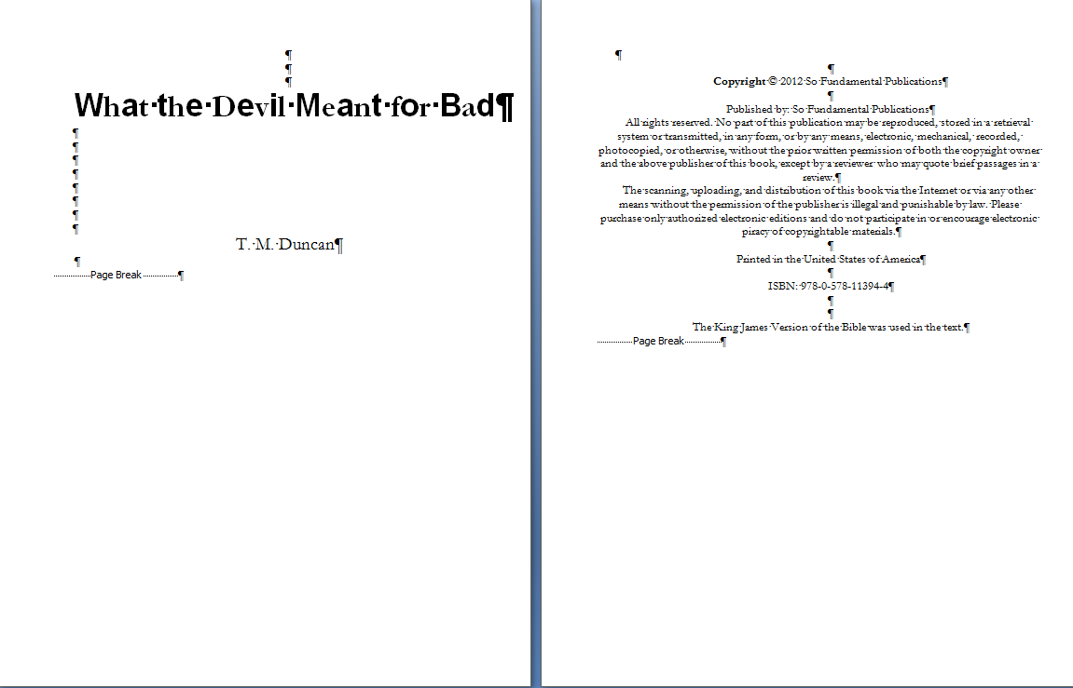

You are done and ready to convert your word document.

