Quick notes:
- Do not indent as you type.
- Do not indent the first paragraph in a novel unless it’s a quote
- Chapter headings vary depending on the vision of the author
- Add page numbers AFTER the book is complete, corrected, and formatted.
- The same as above with headers and footers.
- Title and author name should be center on cover page.
- Cover page, dedication, preface, prologue, copyright, foreword, EVERY chapter should start on its own page.
- Font is up to the vision of the author, but 12 is the default that most use.
- This is YOUR novel and it can look the way YOU want it to.

Basics/ Front Matter

Word Counts: In fiction a book has to be at least 40,000 words to be considered a novel. Some genres have a specific word count.
Classification | Word Count
Novel | Over 40,000 words
Novella | 17,500 to 40,000 words
Novelette | 7,500 to 17,500 words
Short Story | Under 7,500 words

The Front Matter:
  - Since you control how your book looks, it is important for you book to look as professional as possible.
- Cover page
  - If you are using Microsoft word to construct your novel; there are several templates offered to assist. The cover page can be constructed through word under the insert tab.
- Table of contents
  - Table of contents can be inserted and found under the reference tab.
  - Tables have to be formatted different when submitting to ebook stores.
- Dedication
  - This is personalized from you and by you to say whatever you please.
- Introduction
  - Intros are optional. They are mini essays that tell readers about your book
- Forewords
  - Forewords are optional as well and play the same part of an introduction only they are written by someone other than the author and the writer introduces the author.
  - When writing a foreword
  - Write it before the book is published
  - Familiarize yourself with the foreword format: It typically has an opening, a middle, and closing. List your name and the title at the end to complete it.
  - Give your foreword a personal touch. (You can explain how you know the author. Make it credible.)
  - Include anecdotes in the middle.
  - Tell readers what is great about the book.
  - In closing remind readers why you are writing this foreword, why it matters, why it’s important for both author’s careers.
  - Bring it full circle.
- Preface (optional)
  - The preface of a book contains information written by the author to provide the reader with significant background/ information on the book’s contents.
- Prologue
  - A lot of authors usually write a prologue after the book is finished, but it also at the beginning of a book.
  - It’s the opening of a book to establish setting and gives background details, often some earlier story that ties into the main story.

Copyright
The second page in your book.
All copyright pages have the same general information listed. The Book Designer website notes that three things must appear on a copyright page: the © symbol, the word "Copyright" or abbreviation "Copr."; the year of the first publication of the work; and "identification of the owner of the copyright---by name, abbreviation or some other way that it's generally known."
**Note: With POD (Print on Demand) you may not be able to list exactly where your books are printed.**
Sample of simple copyright
Copyright © 2010 by ____________
All rights reserved. This book or any portion thereof
may not be reproduced or used in any manner whatsoever
without the express written permission of the publisher
except for the use of brief quotations in a book review.
Printed in the United States of America (optional depending on printer)
First Printing, 2010 (only needed for separate editions)
ISBN 0-9000000-0-0
Falling Anvil Publishing (only used by publishing companies)
123 Mesa Street
Scottsdale, AZ 00000
www.FallingAnvilBooks.com (this can be the author’s website as well)

Table of contents:
To insert the physical table, go to the references table and select Table of contents. Scroll to insert table. Heading must be “heading 1” to use this feature.
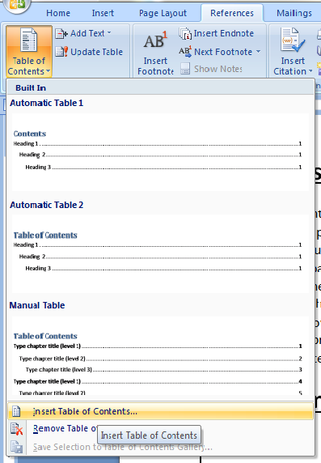
You’re done. Fonts on your table can be set whatever what you like. If you add more chapters later, make sure they are “heading 1” as well and under the reference tab, simply select “update table.”

Indenting:
Use this method to add indentions to your Kindle book. Hitting the enter key and using tab to indent can create unwanted spaces in your kindle book. Spaces will ruin the entire format and it will not appear on Kindle the way it looks on your word document.
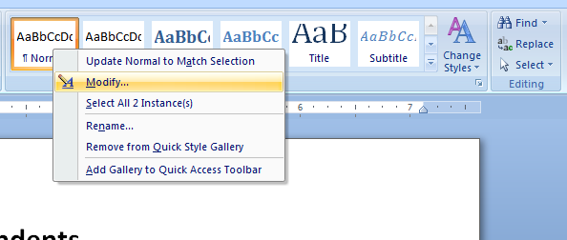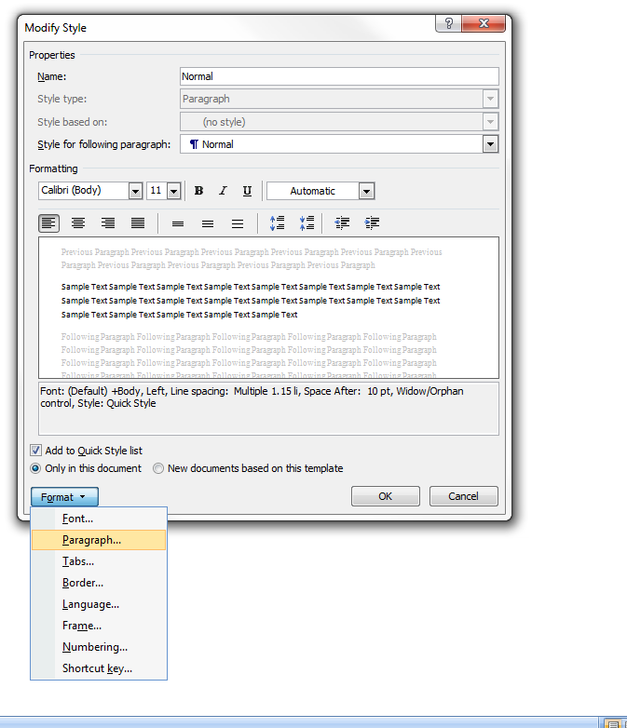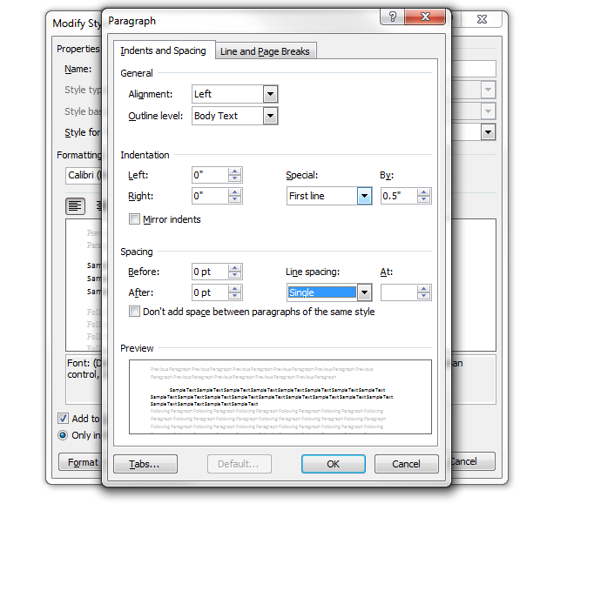

Margins:
These margins may vary based on the company that you print with. Check their guidelines for trims and bleeds.
5x8
Top | .75 | Bottom | .75
left | .75 | Right | .5
Gutter | .13 | Gutter Position | left

- Portrait
- Mirror Margins
- Whole Document
- Ok
5.5x8.5
Top | .1 | Bottom | .75
left | .5 | Right | .5
Gutter | .35 | Gutter Position | left

- Portrait
- Mirror Margins
- Whole Document
- Ok

6x9
Top | .75 | Bottom | .75
left | .75 | Right | .75
Gutter | .25 | Gutter Position | left

- Portrait
- Mirror Margins
- Whole Document
- Ok
6.13x9.25
Top | .5 | Bottom | .5
left | 0 | Right | .5
Gutter | .25 | Gutter Position | left

- Portrait
- Mirror Margins
- Whole Document
- Ok

Formatting:
To avoid unwanted spaces and lines use the show/hide key:
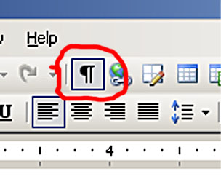
Remove all unwanted spaces.

Page numbers

Start numbering on the second page with 2
If the document does not yet use page numbers, the steps that you follow are slightly different than the steps that you follow if the document already has page numbers.

Documents that do not yet use page numbers
- Follow the steps in this article for inserting page numbers.
- On the first page of the document, double-click in the header or footer area.
- Under Header & Footer Tools, on the Design tab, in the Options group, select the Different First Page check box.
- If you want the first page to use a header or footer that does not include a page number, click in the First Page Header or First Page Footer area, and insert the header or footer that you want.
For more information about creating headers and footers, see Insert headers and footers.

Documents that already use page numbers
- On the first page of the document, double-click in the header or footer area.
- Under Header & Footer Tools, on the Design tab, in the Options group, select the Different First Page check box.
Note If the Different First Page check box is already selected, do not clear it. Instead, delete the page number in the First Page Header or First Page Footer area.
- If you want the first page to use a header or footer that does not include a page number, insert the header or footer that you want while the cursor is in the First Page Header or First Page Footer area.
For more information about creating headers and footers, see Insert headers and footers.

Start numbering on the second page with 1
If the document does not yet use page numbers, the steps that you follow are slightly different than the steps that you follow if the document already has page numbers.

Documents that do not yet use page numbers
- Follow the steps in this article for inserting page numbers.
- Double-click in the header or footer area.
- Under Header & Footer Tools, on the Design tab, in the Options group, select the Different First Page check box.
- In the Header & Footer group, click Page Number, and then click Format Page Numbers.
- In the Start at box, type 0.
- If you want the first page to use a header or footer that does not include a page number, insert the header or footer that you want while the cursor is in the First Page Header or First Page Footer area.
For more information about creating headers and footers, see Insert headers and footers.

Documents that already use page numbers
- On the first page of the document, double-click in the header or footer area.
- Under Header & Footer Tools, on the Design tab, in the Options group, select the Different First Page check box.
Note If the Different First Page check box is already selected, do not clear it. Instead, delete the page number in the First Page Header or First Page Footer area.
- In the Header & Footer group, click Page Number, and then click Format Page Numbers.
- In the Start at box, type 0.
- If you want the first page to use a header or footer that does not include a page number, insert the header or footer that you want while the cursor is in the First Page Header or First Page Footer area.
For more information about creating headers and footers, see Insert headers and footers.

Start numbering after the second page
- Follow the steps in this article for inserting page numbers.
- Place the cursor at the beginning of the page where you want page numbering to start.
- On the Page Layout tab, in the Page Setup group, click Breaks.
- Under Section Breaks, click Next Page.
- On the Insert tab, in the Header & Footer group, click Header or Footer, and then click Edit Header or Edit Footer to make changes in the header or footer area.
The header or footer that contains the page number is labeled Section 2.
Note If the header or footer is labeled First Page Header -Section 2- or First Page Footer -Section 2- and you want the header or footer on the first page of this new section to be the same as the header or footer on the rest of the pages in this section, clear the Different First Page check box in the Options group.
- Under Header & Footer Tools, on the Design tab, in the Navigation group, click Link to Previous to break the connection between the header or footer in the new section and the previous section.
- If you want the numbering on this page to start with 1, in the Header & Footer group, click Page Number, click Format Page Numbers, and then type 1 in the Start at box, and click OK.
- In the Navigation group, click Previous Section , and delete the page number in the header or footer that is labeled Section 1.

YOU ARE DONE!
Well…

Editing:
Be sure to get the following done to your novel before publishing: Developmental/Substantive editing, Copy editing, and Proofreading
Substantive Editing is even more detailed than line editing. It involves the rearranging, deleting, adding and rewording of entire pages and chapters. Some editors call substantive editing a "Ghostwriting/Editing Blend".
Copy Editing is a little more detailed than proofreading. If your manuscript has plot holes, limited characterization, factual errors or syntactical problems, line editing is probably more your style. I would advise you to shop around for line editing to find the best price, as there are plenty of "professional editors" who will try to cheat you out of your money. The purpose of line editing is to tie together loose ends in your manuscript and to make sure that the story flows properly. For non-fiction, line editing will catch factual errors and will also help to separate chapters and paragraphs so that they make more sense.
Proofreading is the simplest form of editing and is also usually the cheapest. Proofreading is for writers who don't need help with sentence structure or the content of the book itself, but need someone to simply go over the text for basic grammatical and spelling errors. The purpose of proofreading is to have someone who has never read your manuscript go over each word for errors that might have escaped your attention, which will happen at least a few times in a full-length manuscript.
Description

Proofreading  Spelling  Capitalization Errors  Typos  Punctuation Errors  Minor Grammatical Errors  Formatting | Full Edit  Spelling  Capitalization Errors  Typos  Punctuation Errors  Minor Grammatical Errors  Formatting  Sentence Structure  Word Choice  Repetitiveness  Grammatical choices  Clarity and Sense  Awkward Phrasing  Rhythm | Rewrite  Spelling  Capitalization Errors  Typos  Punctuation Errors  Minor Grammatical Errors  Formatting  Sentence Structure  Word Choice  Repetitiveness  Grammatical choices  Clarity and Sense  Awkward Phrasing  Rhythm  Consistency  Structural Choices  Characterization  Plot Consistency  Overall Structure  Tie Up Loose Ends  Momentum

Now you’re done!

